Professional Engineering Panel Discussion Session

Moderator: Dr. Andrea Burrows, GK-12 and RET Grant Coordinator, University of Cincinnati
Date: July 26, 2011
Times: 9:00 - 11:30 AM
Venue: University of Cincinnati, Teacher’s College room 430

Prepared by:
Each RET Team was assigned one panelist and asked questions of this panelist
Each RET Team prepared the write-up for their panelist
This is a collection of these writings

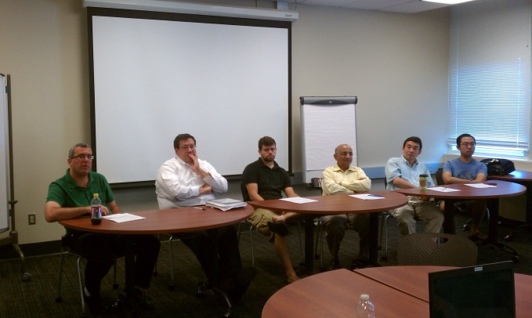
(a) (Left to right) Mr. Elad Kivelevitch, Dr. Anastasios P. Angelopoulos, Mr. Mike Borowczak, Dr. Anant R. Kukreti, Dr Heng Wei, and Mr. Feng Wang
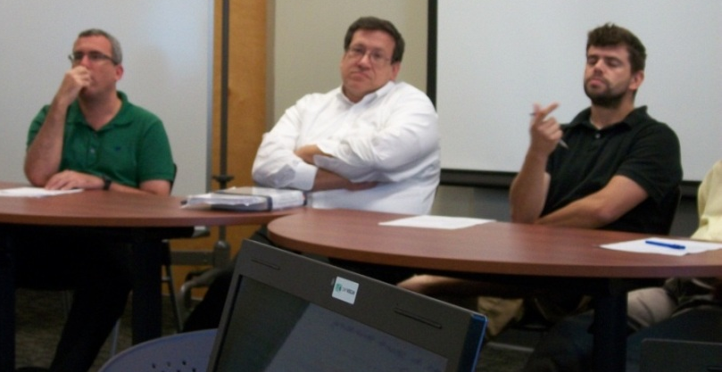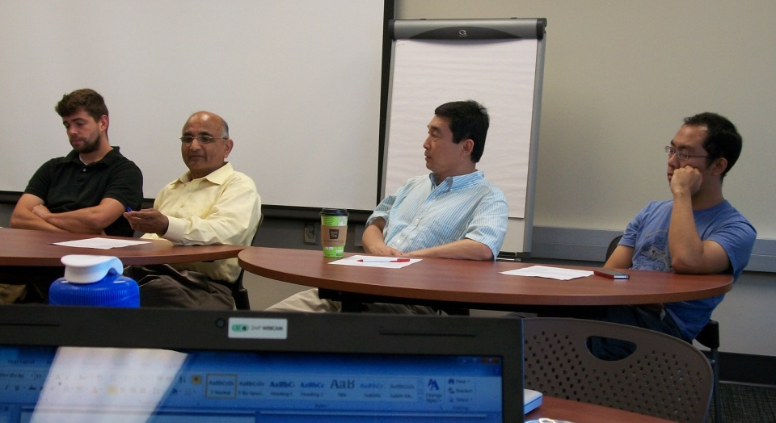
(b) (Left to right) Mr. Elad Kivelevitch, (c) (Left to right) Mr. Mike Borowczak,
Dr. Anastasios P. Angelopoulos, Dr. Anant R Kukreti, Dr. Heng Wei,
and Mr. Mike Borowczak and Mr. Feng Wang
Professional Engineering Panelists
As one of the final seminars in the RET program, an Engineering panel discussion was held between the RET participants and six engineering faculty and graduate students. The session was moderated by Dr. Andrea Burrows. The six panel members were at various stages in their careers and represented a number of different cultural and educational backgrounds and experiences. All had also worked in the industry in the past. In turn, the panel members shared information about their specific research interests and career paths, and also thoughts and beliefs about the Engineering profession. Each panelist was given about 9 minutes for an introduction and to allow them to present their view points on a few of the general topics listed below:
- How to enhance student interest in engineering and science.
- How to increase the visibility and importance of engineering and science to society.
- How to underscore the importance of recognizing that engineering education must be coupled to policy/business/law and must be student-focused.
- How to enhance student interest in engineering, science, and technology entrepreneurship.
- How to foment future collaborations of interested scientists, engineers, policy makers and researchers in business, law, social sciences and humanities needed to successfully address these complex societal issues.
The panelists were sent this list in advance and each pre-selected the topic they will talk about relating it their personal experiences. It was ensured that all the topics were covered. This allowed the teachers to understand the panelist's backgrounds/perspectives before asking their questions. The pictures above show the six panelists.
After the panelists shared their own background and ideas, the RET teachers were given the opportunity to ask a wide array of questions relating to engineering and also to education. A number of different opinions were expressed, and many good ideas were suggested. However, all the panelists seemed to agree that instilling an interest in math and science at a very young age is paramount to the United States making progress as a scientific and technological nation. Each RET team was responsible for recording the information and ideas presented by one panelist. Their notes are presented below.
Panel Member # 1 - Mr. Elad Kivelevitch, Adjunct Faculty Member and Ph.D. Student of Aerospace Engineering: Mr. Kivelevitch was born 1974 in Israel. He holds a B.Sc. (1997) and M.Sc. (2005) in Aerospace Engineering, both cum laude, from the Technion – Israel Institute of Technology. From 1997-1999 he was a flight principals instructor at the Israeli Air Force Academy. From 1999-2008, Mr. Kivelevitch worked as a systems engineer in areas that include unmanned aerial vehicles, control systems, and data fusion. In 2008, he joined the University of Cincinnati and since then has been holding the position of Visiting Research Associate with the School of Aerospace Systems in the College of Engineering and Applied Sciences. In the last three years Mr. Kivelevitch has taught 20 class sections and 6 different classes and in Spring 2011 was honored by his students, who selected him as the College of Engineering and Applied Sciences Professor of the Quarter. In addition, Mr. Kivelevitch has been working on his Ph.D. under the supervision of Dr. Kelly Cohen, School of Aerospace Systems, and Manish Kumar, School of Dynamic Systems, and hopes to graduate in June 2012.
The main story that Mr. Kivelevitch told related to a problem he had keeping in touch with an old girlfriend. It was 1995 and she had moved out of the country to pursue her career. He discussed the struggles of trying to maintain a relationship with no Internet, unaffordable international calling rates, and the delay in posting mail between Germany and Israel. Mr. Kivelevitch mentioned the advances in technology that have made long distance communication much easier over the last 15 years: email in 1996, Skype audio conversations in 2003, and Skype video chats in 2005, stating how much easier it has become for people to stay in touch on a personal and corporate level.
Mr. Kivelevitch stated that change is here, whether good or bad, but it’s here. Engineers can help to cause changes because they are creatures who seek inefficiencies with time and money and strive to solve them. He also mentioned that we have to live through the change through STEM (science, technology, engineering, and mathematics), and added the additional component of entrepreneurship. He discussed the importance of the labor market, and how that infrastructure in America has been forever changed by deployment of robotics in manufacturing and availability of cheaper labor outside of the United States. Mr. Kivelevitch said that the privatization of the labor market will continue, so we must push the best and brightest to the top, because cheap labor is difficult to compete with. At the conclusion of the presentation portion of the panel, he discussed how skills such as analytical and critical thinking are timeless.
Some of Mr. Kivelevitch’s key points from the question and answer portion of the panel discussion provided great insight. On advantages and/or disadvantages of going straight from graduate school to Ph.D. instead of gaining career experience first, he said that either can be acceptable if the person is able to go from the non-concrete thinking of academia to the concrete problems of the real world. Sometimes coming after working in the industry to do a Ph.D. degree offers an advantage – it provides the ability to link the doctoral research to real world applications rather than it being a challenging theoretical technical problem. They bring a practical aspect to basic research more readily. Regarding cooperative learning and collaboration, he suggested reducing group size, as having a group of 4 often leads to one student being a “free loader.” Another interesting suggestion was having each student provide a short report about what exactly they did to help the project get accomplished. This discourages apathetic behavior in groups. In order to get students thinking about “unconventional methods” for getting things to work, Dr. Kivelevitch suggested critical thinking to be of paramount importance. Ask students to find something that doesn’t work for them, and brainstorm how they could make it work. Finding an annoying or inefficient problem is 50% of the battle. He also suggests that by encouraging this behavior in younger students, it is possible to capture their creativity and encourage them to not shut down over time.
Panel Member # 2 - Dr. Anastasios P. Angelopoulos, Associate Professor of Chemical Engineering: Dr. Angelopoulos earned his Ph.D. from Princeton University performing research on colloids and surfaces in the 1990’s before coming to work at the University of Cincinnati. He considers the research which he has done at University of Cincinnati to be an outgrowth of the work that he completed while earning his doctorate. Dr. Angelopoulos also had extensive industrial experience before joining the university as a faculty member. He previously worked as an engineer at General Motors checking automotive failures and also as a Process Engineer at IBM. Dr. Angelopoulos acknowledged that there is significant collaboration between academics and industry. He also expressed his belief about the importance of teaching American High School students that the world is much broader than the small world which they know. He feels that the majority of students in the U.S. have no idea what skills they are going to need to succeed in the future. Dr. Angelopoulos believes that students often make bad choices simply because they are not focusing on the road ahead. He believes that the youth could greatly impact the future of this country if they realized that engineering has substantial influence on the world in the fields of law, medicine, politics, etc.
Panel Member # 3 – Mr. Mike Borowczak, Ph.D. Student in Computer Engineering and Science: Mike was born in North Kenton, Ohio and is currently working on his Ph.D. in Computer Engineering and Science. He has worked at Texas Instruments and a software company as a quality engineer. Since Mike began working at University of Cincinnati he has focused on outreach to the high schools and younger students. He has seen the impact that introducing students early to science and engineering can open the student’s eyes to opportunities. He stated, “Students need to realize the point of engineering, to the importance of engineering.” The panel of engineers echoed Mike’s thoughts. All hope to enlighten students to the fact that engineering is not just for those who excel in math and sciences, that anyone can become an engineer and to not limit one’s possibilities or potential. Many expressed that students today do not see the broader picture of how they can help to impact the world and society.
Panel Member # 4 – Dr. Anant R. Kukreti, Director for Engineering Outreach: Dr. Kukreti being the Principal Investigator of the RET grant was acquainted to all participants. Through many of his other educational NSF funded projects and K-12 outreach efforts, many of the RET participants had in the past worked with him. Dr. Kukreti had very much insight to share regarding his career experiences. He began by sharing with us who he was most impacted by and why. As a graduate student, his graduate advisor was very meticulous and stressed on developing good communication skills, both in writing and speaking. He learned under his advisor’s tutelage significant relevance of having very good writing format skills. One’s writing should be interesting to read and should explain intricate scientific details in simple but lucid manner. Writing (and speaking) is the most important way to convey a message to both scientists and non-scientists. Effective writing thus became a habit with him.
Dr. Kukreti also shared an experience he had as the manager at a construction site. During the construction of a steel bridge, which was being launched over a river gorge, due to malfunctions of some of the roller bearings the nose of the bridge got misaligned by few feet when half of the bridge was hanging in the air over the gorge – he had to immediately think of something to prevent it from crashing before its completion. Dr. Kukreti was initially at a loss as to how to approach to fix to the problem. He asked his foreman for advice and through their communicating he was reminded of learning from his “statics” class in college and thus resolved the problem. The advice here is recognizing the value of communicating with resources and the realization that engineering is “common sense.” To this point he says, “Give problems to students which involve a design challenge for which they cannot apply a standard solution.” They then become owners of their education.
Finally, in regards to experience sharing, Dr. Kukreti spoke of a project situation involving families living in a slum area. Families were provided with “free” new homes through funds provided by another country. The homes were built without any communication occurring between the providers and the potential homeowners. As a result, the people refused to move into the homes preferring to stay in their slum environment because the homes were not built consistent with their lifestyles. Moral of the story; societal impacts and acceptance are often the deciding factor for success.
In terms of the open forum, Dr. Kukreti responded as follows to the following questions;
- What are the advantages and disadvantages of obtaining work experience prior to obtaining a Ph.D.?
Advantages: Having developed better problem-solving skills being in real world job situations. There are often more job opportunities for Ph.D. graduates who have prior industrial experience. Often some start their own consulting companies – Dr. Kukreti said that some of his students have done this.
Disadvantages: Very difficult to manage the financial lifestyle change due to not having the income in college you realized as a professional in the field.
- Why are students from Asia and India more academically astute than American students?
High School teachers in India generally must have a Master’s degree in their content area. “Passing” scores are more stringent in India. Unprepared students are held back starting from earlier grades, which is often not the case in U.S. A teacher’s success is not measured blindly by how many students advanced to the next grade.
- How does a teacher incorporate requirements that would require “all” students to participation?
Give group projects and assign requirements for member participation. Make these as design challenge projects which force the students to seek various solutions and opportunities to tap into the talents of individual members, for example, one of the members may be excellent in making drawings.
- What are the “unconventional methods” for getting things to work?
Choose everyday common problems for students to provide their “own” solutions. Choose problems which provide opportunities for authentic learning (something they can relate to their daily lives).
Panel Member # 5 – Dr. Heng Wei, Associate Professor of Transportation Engineering: Dr. Wei joined University of Cincinnati in December of 2004 as an Assistant Professor. Prior to that, he worked at a consulting firm dealing with intelligent transportation and research. He has also worked as a professor at the University of Southern California. He received his Ph.D. from the University of Kansas. Prior to coming to the U.S., he worked in Beijing, China designing transportation system. He said that transportation engineering is a continuously changing field based on research and knowledge gained. One example is that prior to 1994 conventional wisdom was that when the traffic volume reached 90% of capacity, this was considered to be a congestion situation. This however is not always the case. Dr. Wei discussed the importance of common sense in transportation engineering. He said that traffic engineering uses a wide range of software and hardware to help in the analysis of traffic flow. The one thing that can't be left out is common sense. We have experience using this approach to traffic: keep things simple, manageable, and sustainable. Traffic engineers do not have the time to do many of the things that they would like to do, so applying some engineering judgment will help expedite the projects. This also translates to the business side of the industry. For example, the cost associated with collecting data can be very high. So, for a solution, find partners in industry and rent equipment to get the data at a cheaper price. Dr. Wei stressed a three step process that engineers must gain prior to graduation:
1. Ability to identify the problem.
2. Ability to find a practical, affordable and sustainable solution to the problem.
3. Ability to evaluate the solution to the problem.
Dr. Wei answered the question, “How to use unconventional methods in the classroom”. His response was that critical thinking and creative thinking skills are both important in problem solving and getting students to solving complex problems which do not have a unique solution. These types of thinking must be used in the classroom with real world examples that students can relate to.
Panel Member # 6 – Mr. Feng Wang, Ph.D. student in Materials Engineering: Mr. Feng Wang is currently a 4th year Ph.D. student in Materials Engineering at University of Cincinnati. He got his B.S. degree in Composite Materials from Nanjing University of Technology, China in 2005 and came to University of Cincinnati to pursue his Ph.D. degree in 2007. His current research is to design drug delivery systems using iron oxide nanoparticles and carbon nanotubes. His interest also includes making dye sensitized solar cells (DSSC) with titanium dioxide and graphene. Mr. Wang spoke of his experience elaborating upon the idea that he was still coming from the student perspective. As a student in his country he didn’t have enough guidance to be able to choose what he should study after high school. Most of the students in his country were more interested in areas of study that pertained to business than engineering because of the greater potential to earn more money. He obtained admission into Materials Engineering as a field of study, but he was not that much interested in the subject to start with. He decided to apply himself anyway. He took all of the courses that pertained to general engineering but it wasn’t until his final year when his advisor took his entire class to many different factories that he really developed an appreciation of his field. It wasn’t until he was able to see the entire process at these factories, going from powder to polymers and then the end product, that he truly could appreciate the impact that his studies has on society. This made him realize his value as a materials engineer. In his class, twenty seven out of twenty nine students chose to stay in engineering and all twenty seven are still doing engineering today. Six have started their own businesses and one owns a company that generates revenue of $500,000,000 each year.
The panel discussion ended with a Social Lunch Mixer to mingle, eat, and hold smaller group discussions.

